1. Program to depict inline function (without class) for calculating area of a circle.

#include <iostream>

using namespace std;

const float Pi=3.14;

inline float areaOfCircle(float radius)

{

return Pi*radius*radius;

}

int main()

{

float radius;

cout<<"Enter the radius of a circle : ";

cin>>radius;

cout<<"The area of the circle is : "<<areaOfCircle(radius)<<" sq units"<<endl;

return 0;

}

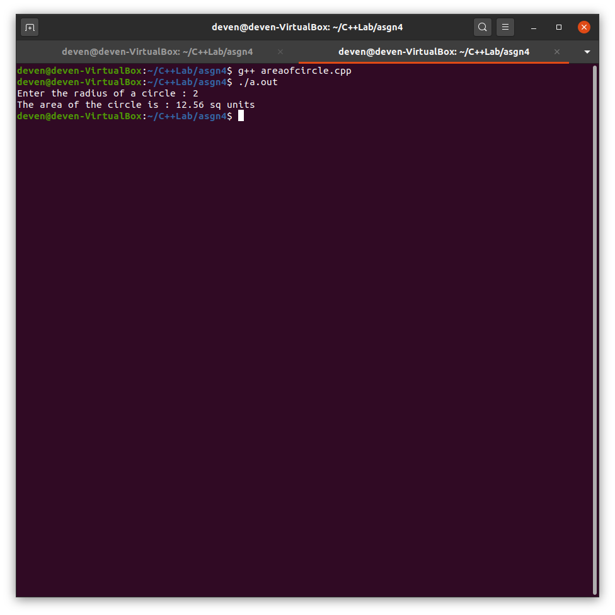

1. Program to depict inline function for a class named MathWorks to add, sub, mul, div on two numbers.

#include <iostream>

using namespace std;

class MathWorks

{

private:

int x, y;

public:

MathWorks(int x=0,int y=0):x(x),y(y){}

void read()

{

cout<<"Enter two integers :";

cin>>x>>y;

}

int add()

{

return x+y;

}

int sub()

{

return x-y;

}

int mul()

{

return x*y;

}

int div()

{

return static_cast<float>(x)/y;

}

void disp()

{

cout<<"The two integers are : "<<x<<" "<<y<<endl;

}

};

int main()

{

//MathWorks m(10,5);

MathWorks m;

m.read();

m.disp();

cout<<"The sum of the two integers = "<<m.add()<<endl;

cout<<"The difference of the two integers = "<<m.sub()<<endl;

cout<<"The product of the two integers = "<<m.mul()<<endl;

cout<<"The quotient on division of the two integers = "<<m.div()<<endl;

return 0;

}

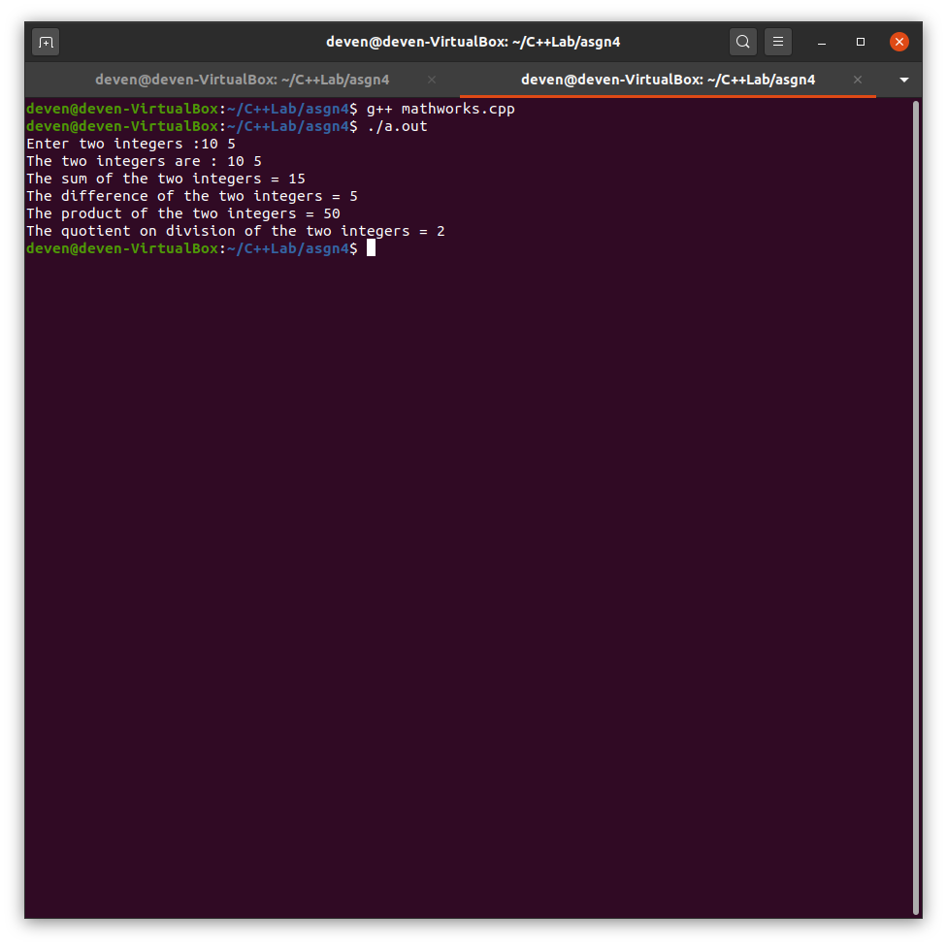

1. Program to depict default arguments (without class) to calculate volume of a cylinder. Consider all types of functions to show characteristics of trailing arguments.

#include <iostream>

using namespace std;

const float Pi=3.14;

inline float volume(float radius=1, float height=1)

{

cout<<"The volume of the cylinder with radius = "<<radius<<" and height = "<<height<<" is : ";

return Pi*radius*radius*height;

}

int main()

{

float radius,height;

cout<<"Enter the radius and height of a cylinder : ";

cin>>radius>>height;

cout<<volume()<<endl;

cout<<volume(radius)<<endl;

cout<<volume(radius,height)<<endl;

return 0;

}

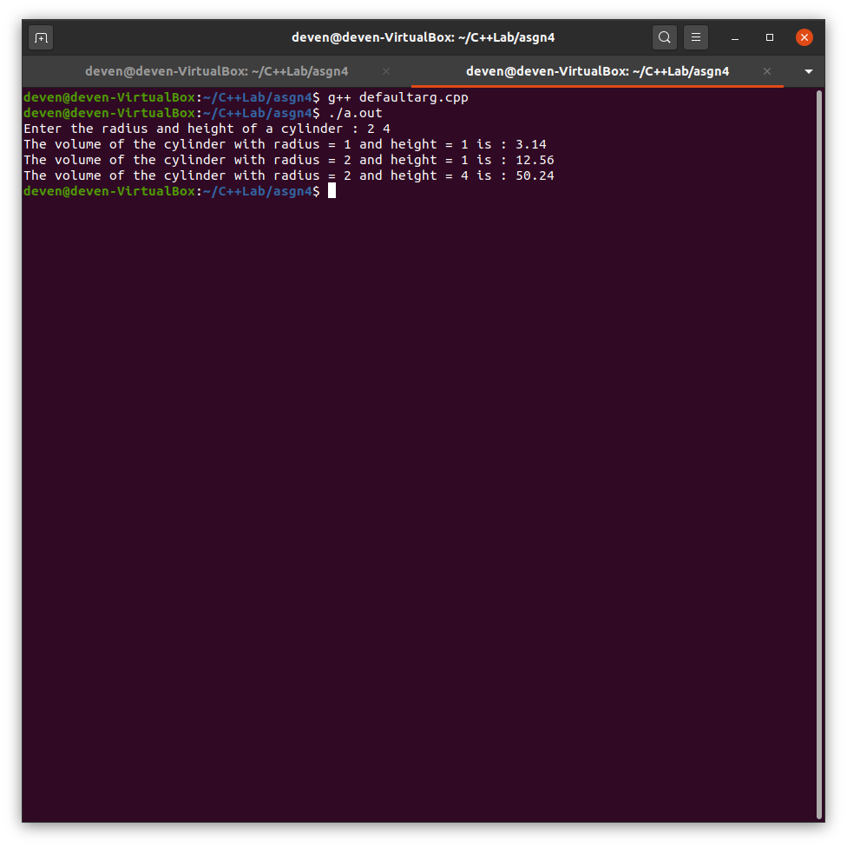

1. Program to depict Compiling of multiple files (without class), with class using .h files for printing multiplication tables of given number 'n'.

//table.h

void printTable(int);

//table.cpp

#include <iostream>

using namespace std;//for cout

void printTable(int n)

{

cout << "Table of " << n << " : " << endl;

for(int i = 1; i <= 10; ++i)

cout << n << " x " << i << " = " << n * i << endl;

}

//main.cpp

#include <iostream>

#include "table.h"

using namespace std;

int main()

{

int n;

cout << "Enter a number : ";

cin >> n;

printTable(n);

return 0;

}

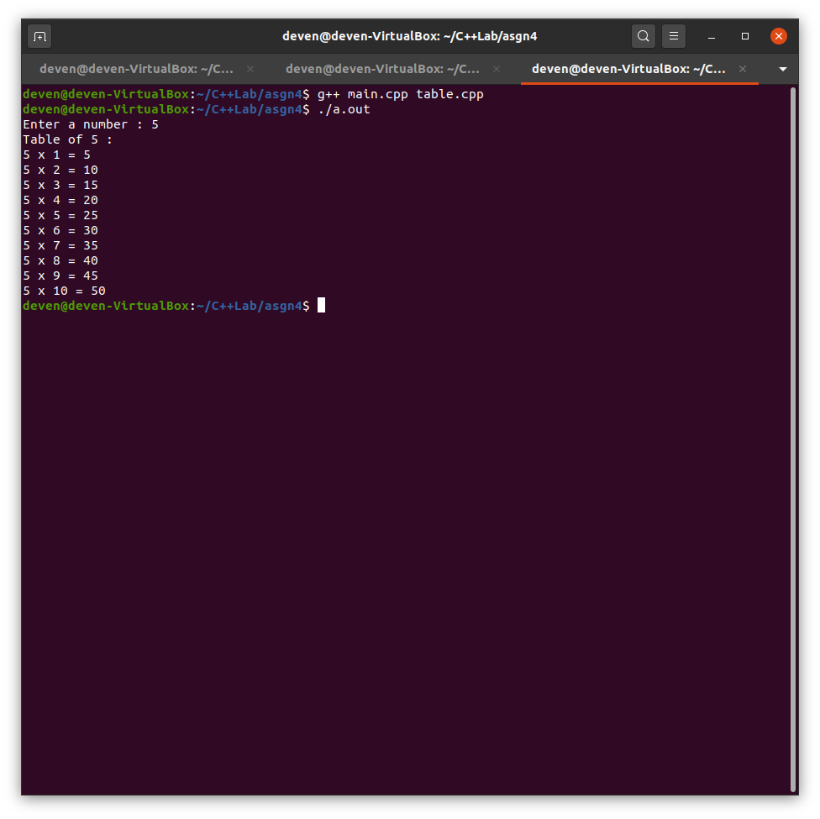

1. Program to depict command line arguments to compute fibonacci number of nth term.

#include <iostream>

#include <cstdlib>

using namespace std;

int fibonacci(int n)

{

if(n == 1)

return 0;

if(n == 2)

return 1;

return (fibonacci(n - 2) + fibonacci(n - 1));

}

int main(int argc, char *argv[])

{

if(argc < 2)

{

cout << "Input fail" << endl;

exit(0);

}

int n = atoi(argv[1]);

if(n <= 0)

{

cout << "Wrong Input" << endl;

exit(0);

}

int num = fibonacci(n);

cout << "The " << n <<"th number of the fibonacci series is : " << num << endl;

return 0;

}

